Chapter 9, Problem 62.

For the circuit in Fig. 9.69, find the input impedance Z_{in} at 10 krad/s.

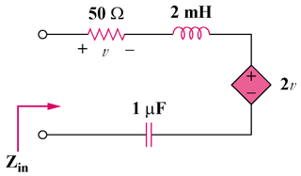

Figure 9.69
For Prob. 9.62.

